1. Now we have data in the cluster & we can get the data, if we have the key.
2. But what if we want to search for data like we search in DB.
3. **For Example**: We want to search all the customers whose DOB within in a specific range.
4. 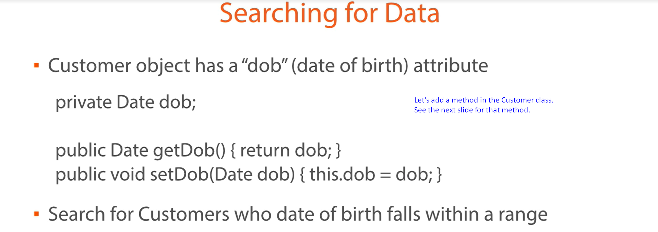
5. Graphical user interface, text

   Description automatically generated
6. Let’s write the test case.  
   The following is utility method to generate N number of customers.  
   Graphical user interface, chart

   Description automatically generated  
   The following is **@Test** method.  
   Graphical user interface, text, application

   Description automatically generated  
   
7. **Predicates**:  
   There are a number of out-of-box predicates available.  
   Text

   Description automatically generated with low confidence